**Product Specifications Report**

1. **Introduction:**

Methods to check a bridge’s health are important in ensuring the safe transportation of vehicles and pedestrians. To assess the condition of a bridge, the response of its natural frequencies, damping, and mode shape vibration under a dynamic load must be experimentally obtained [1]. The shaker is meant to be an easy-to-use, portable, and robust instrument that gathers and displays data to the user concerning power, frequency, and energy applied. The aim of this project is to excite the bridge to certain frequencies and gather data that could aid other researchers in differing experiments which require the need for a bridge shaker. These needs and requirements are summarized below in the form of a needs matrix, needs metrics matrix, and a target and fallback specifications table.

1. **Needs Matrix:**

When deciding the needs for the bridge shaker, redundancies in the previously defined needs were identified by the group to create a more concise list. Fifteen out of the original 36 needs were kept. Each need was evaluated individually to determine the importance of the characteristic for the final product. Some needs such as site flexibility, minimal invasiveness, and small size were cut in favor of portability as a need. Ways to validate the performance of each customer need were brainstormed in order to come up with metrics and their corresponding units. Each metric and unit were collectively discussed in relation to each specific need.

Table 1: Needs Matrix

The client required an accurate way of measuring the desirable characteristics for excitation over an extended period to test structural integrity of a bridge. This meant that the shaker would need to operate at different frequencies to recreate the modal frequencies of the bridge. This project would ideally be well documented, with data while using the shaker being recorded, as well as a time control on the shaker to supply timed testing. The client also recommended safety and ease of use so that researchers could comfortably use the shaker for vibration experiments. After further discussion, the bridge shaker needed to be robust, have good contact with the bridge, and leave the bridge undamaged. These characteristics were clear needs for the shaker to meet the purpose of a long lasting and useful experimental tool. All the needs discussed were organized into Table 1 with the units and metrics included.

1. **Needs Metrics Matrix:**

*Table 2: Needs metrics matrix.*

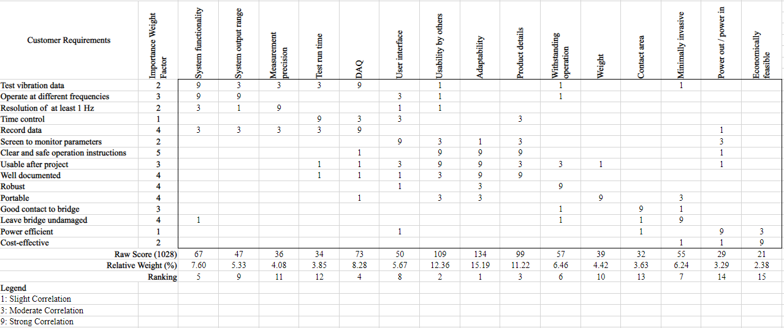 The needs metrics matrix is presented in Table 2 as a method of determining relationship strengths between customer requirements (CRs) and engineering characteristics (ECs), as well as determining which engineering characteristics are most significant. After the list of needs was refined and each need translated into a CR, an importance weight factor was assigned to each CR. This weight factor ranged from 1-5 with 5 being the most important, and needs were ranked relative to one another. This was done as a group to consider all factors collectively. Next, the corresponding ECs and metrics were listed along the top of the matrix and the improvement direction of each EC was determined by the group, which contextualized each need relative to the entire project. After this, the ECs were divided among the team members and the correlation of each EC with the different CRs was ranked with a 0, 1, 3, or 9 for no, low, medium, or high correlation. The ranking is divided up here to consider each EC independently from the other ECs and reduce group member influence on the scores, as the strength coefficients could be scored more objectively than the importance weight factors. The EC strength coefficients were limited to 0, 1, 3, or 9 to reduce the subjectivity of the scoring method by eliminating “in-between” scores. Once all strength coefficients had been assigned, the raw value and relative weight of each EC was calculated and ranked to determine the most significant ECs. It was found that the most significant ECs, which are ranked 1-3 and represent the 80th percentile, are the system’s environmental adaptability, its usability by others, and the documentation of product specs. The priority CRs were found to be the ability to test vibration data and the usability of the system by future students.

1. **Target and Fallback Specifications:**

Table 3: Target/Fallback Specifications.

Determining target and fallback specifications is vital to the success of the product. Finding values or parameters that suit the sponsor's needs is time-intensive and important so that the satisfaction of the sponsor is met. Using previous experiments, opinions, and others' expertise to determine logical values is what produces a good product. For the shaker, multiple sources were found that had identical or similar experimental ideas and setups. From these, several target and fallback specifications were determined. Some specifications came from the direct wants of the sponsor and others came from researchers in the field. Lastly, a few came from theoretical ideas that are ingrained in the basis of engineering. Specific reasons for why the target and fallback specifications were chosen can be found next to the source in the **References** section. All metrics, units, target, and fallback specifications can be found in Table 3.

1. **Conclusions:**

This project will focus on the creation of a bridge shaker with the ability to excite bridges to the target frequencies specified in the Target Specifications Table. The primary requirement of this project is the adaptability of the shaker for other engineering projects. Therefore, the shaker must be well-documented and intuitive to use by others. One of the main challenging specifications for this project will be to ensure the vibrations and forces generated by the shaker will not damage its own components. One critical specification worth noting will be to ensure the shaker will produce an adequate force to induce an output range with a maximum of 30 Hz.

1. **References:**
2. Earlier work done by the ARTS Lab suggests that the optimal operation range to be between 0-30Hz. (<http://www.me.sc.edu/Research/Downey/publications/Posters/Yount2022DroneDeliverableVibration.pdf>)
3. The accelerometer suggested by Dr. Austin Downey has a sensitivity of anywhere between 0.03-0.1 Hz which is a good standard to compare the product to. (<http://www.me.sc.edu/Research/Downey/resources/data_sheets/Vibra-metircs_models_1030.pdf>)
4. Using a lecture from Dr. Saif Thamer Al-Zubaidi, efficiency of a large motor, fully loaded, can be as high as 90%. (<https://uomustansiriyah.edu.iq/media/lectures/5/5_2020_04_05!03_11_12_PM.pdf>)
5. The APS 400 data sheet has numerous shakers that have already been developed and tested. From this information, several metrics such as force (445N), weight (73kg), and contact area (95% SA) were decided. (<https://www.apsdynamics.com/en/products/details/vibration-exciter/aps-400.html>)
6. Joud Satme’s research is closely related to that of the product being developed, therefore he was able to supply the ideal test run time of 75-300 seconds. (Interview with stakeholder Joud Satme)
7. Dr. Austin Downey supplied information on the user interface desired, the way to document product details (GitHub), the budget (<$1000), and the invasiveness of the shaker. (Interview with sponsor Dr. Austin Downey)
8. Research done by the ARTS Lab and associated professors has confirmed the validity and usefulness of a data acquisition system using LabView. Using this program makes the product easy to use by others as well as being able to adapt to varying projects. (<http://www.me.sc.edu/Research/Downey/publications/Journal_publications/Smith2022UavRapidlyDeployable/Smith2022UavRapidlyDeployable.pdf>)